**Practical 3**

|  |  |
| --- | --- |
| Roll No. A016 | Name: Varun Khadayate |
| Program : B.Tech | Division: CsBs |
| Batch: 1 | Date of Experiment: 04-08-2020 |
| Date of Submission: | Grade : |

**(PART – A)**

***Aim: To generate Regular expression of designed Deterministic finite automata using JFLAP simulation tool***

**Outcome:** After successfully competing of this practical, students will be able to learn:

* Designing of DFA using JFLAP tool
* Convert DFA into regular expression

**A.1: What is regular expression?**

* The language accepted by finite automata can be easily described by simple **expressions** called **Regular Expressions**.
* A **regular expression** can also be described as a sequence of pattern that defines a string.
* **Regular expressions** are used to match character combinations in strings.

A.2: More examples of regular expression

* Starts with bba

bba (a+b) *

* Ends with ab

(a+b) * ab

* Starts and ends with b

a + a(a+b) *a

* Starts and ends with different symbol

a(a+b)*b + b(a+b)*a

* Strings with even number of a’s followed by odd number of b’s

(aa)*(bb)*b

A.3: Equivalence of DFA and RE

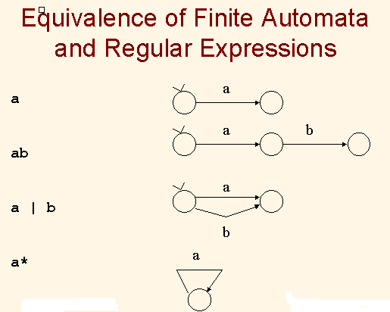

**A.4 Tasks**

1. Design DFA and convert into regular expression using JFLAP for the given problems:
   1. “Construct a DFA where 2nd symbol from right end is always b over ∑ = {a, b}”
   2. Construct a DFA for language L = {w mod 5=2: wϵ (a,b)*}
2. Test the designed DFAs using multiple inputs strings: babba, aabaab, bbbbbbb
3. Convert DFA into regular expression

**PART B**

(PART B: TO BE COMPLETED BY STUDENTS)

**(Students must submit the soft copy as per following segments within two hours of the practical. The soft copy must be uploaded on the Portal or emailed to the concerned lab in charge faculties at the end of the practical in case the there is no portal access available)**

**B.1 Output:**

1. Write the procedure to design the DFA of given problems using JFLAP tool
   1. Create the number of states using state creator.
   2. Assign the initial and final states using attribute editor.
   3. Draw the transition between the states using transistor creator for the given transitions.
   4. Mark the input value of each transition.
   5. Go to convert option and select convert DFA.
   6. Test the input to check if the automata are designed correctly.

**Ans:**

**PART I**

The expression will be **(b* + a*) * ba**

The procedure to design DFA using JFLAP tool is as follows:

1. Open JFLAP tool. Select Finite Automation and it will open a new window.
2. Select state creator and create 5 states.
3. Select Attribute Editor. Right click on state q0 and select it as initial state.
4. Right click on state q3 and q4 and put final state.
5. Select Transition Creator. Click on q0 and add transition ‘a’.
6. Drag from q0 to q1 and mark transition ‘b’.
7. Drag from q1 to q2 and mark transition ‘a’.
8. Click on q2 and add transition ‘a’.
9. Drag from q2 to q1 and mark transition ‘b’.
10. Drag from q1 to q3 and mark transition ‘b’.
11. Click on q3 and add transition ‘b’.
12. Drag from q3 to q4 and mark transition ‘a’.
13. Drag from q4 to q1 and mark transition ‘a’.
14. Drag from q4 to q1 and mark transition ‘b’

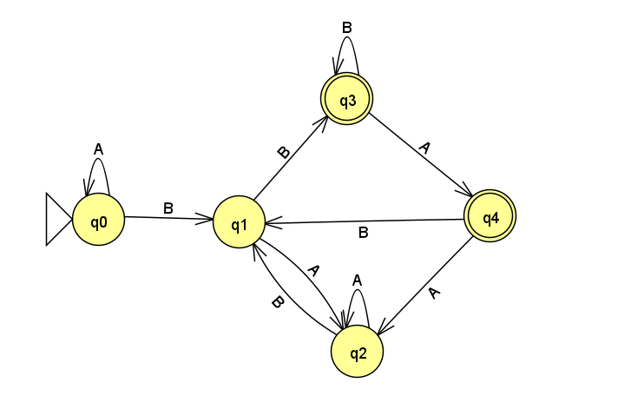

**PART II**

Given expression is **L = {w|5 = 2: w ε (a, b)*}**

The procedure to design DFA using JFLAP tool is as follows:

1. Open JFLAP tool. Select Finite Automation and it will open a new window.
2. Select state creator and create 5states.
3. Select Attribute Editor. Right click on state q0 and select it as initial state.
4. You can rename the states if youwant.
5. Select the Transition Creator tool and draw transitions ‘a’ and ‘b’ from initial to every next state by dragging the tool from previous state to the next state. Draw transition from last (5thstate) to the initial state as shown in the diagram below.
6. Since ‘w mod 5 = 2’, set state 2 as final state.

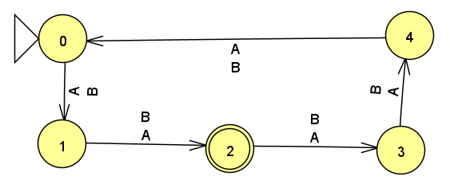

1. Run simulated DFA by giving various input strings (as given Part A under Task section)

**ANS:**

**PART I**

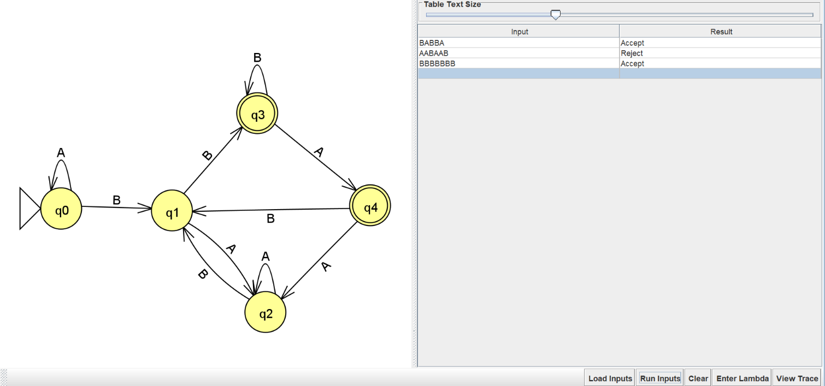

**PART II**

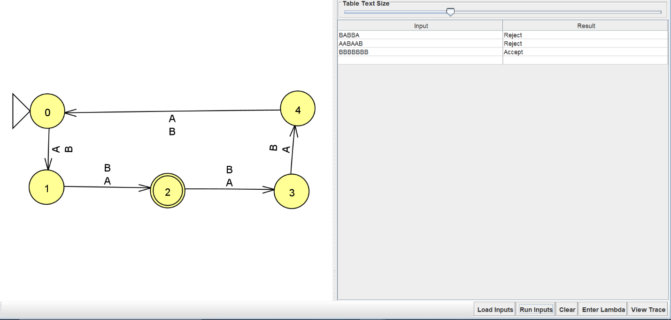

1. Covert designed DFA into regular expression using JFLAP tool

**ANS:**

**PART I**

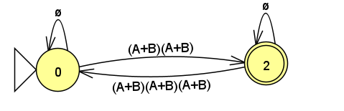

**PART II**

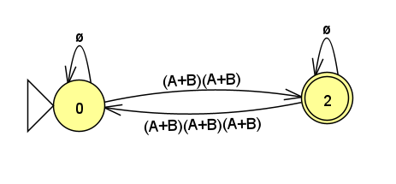

**B.2 Observations/Learning**

*(Students are supposed to write the logic of constructed DFA and generated regular expression)*

DFA should have non-ambiguous transitions for each state. For regular expression, there should be only one final state and epsilon transitions between two transitions.

**B.3 Conclusion:**

*(Students must write the conclusion as per the attainment of individual outcomes and learning/observation)*

The above experiment was successfully performed and the concept of converting a DFA to regular expression was practically carried out.

***B.4 Curiosity Question***

***Can you generate a general formula to find total number of states when positions of particular input is fixed from left hand side? Explain***